Small and powerful - maximum performance in the smallest of spaces
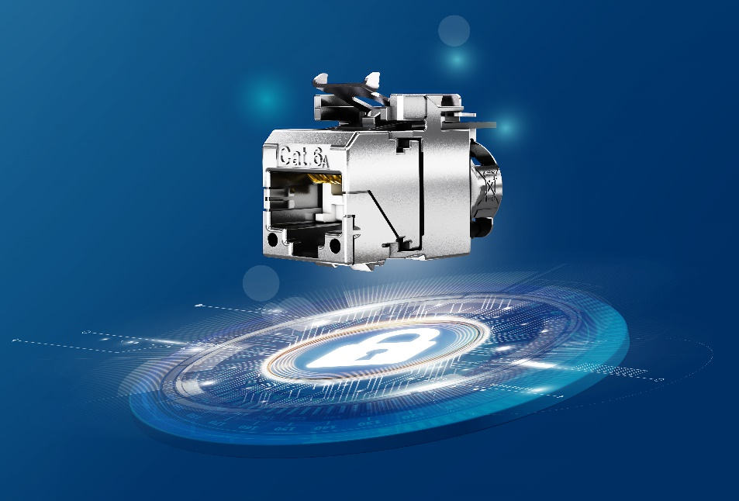

IT cabling often has to be installed in extremely confined spaces. This has a particularly critical effect on the junction boxes: The minimum bending radius of the cable must not be undercut for reliable data transmission, but most RJ45 modules are quite long and take up a lot of space. However, a short design and high transmission performance are not necessarily mutually exclusive. The new AMJ-SL from Telegärtner offers transmission values that far exceed the requirements of the standards, and its particularly compact design at the same time leaves enough space for correct cable routing.

"With its extremely short overall length of only 32 millimetres, the AMJ-SL is up to 37% shorter than comparable Category 6A modules," says Marcel Leonhard, head of the DataVoice business unit at Telegärtner. "Together with its excellent transmission parameters, it is the ideal solution wherever high system reserve is required but there is hardly any space available for the module and cable. In other words, our module leaves the cable the space it needs for secure data transmission."

Short RJ45 modules can easily outperform larger and longer modules in terms of transmission values. The AMJ-SL is certified by the independent testing laboratory GHMT to Category 6A in accordance with IEC and EN 60603-7-51 with Type Approval Component Cat.6A. The power supply of the end devices through Four Pair Power over Ethernet (4PPoE) with currents of up to 960 milliamperes was taken into account from the outset during development. Due to the optimised contact design, damage caused by sparks during unintentional pulling under load does not affect the functionality of the module: The contact area where data is transmitted is spatially far separated from the area where unavoidable damage from breakaway sparks occurs.

Small and fine - sometimes less really is more.

Telegärtner, founded in 1945, is a globally operating full-range supplier for professional solutions in connection and transmission technology and is one of the most important manufacturers. The family-owned company, rich in tradition, is already being managed by the third generation. With around 660 employees worldwide, the group generates annual sales of up to 100 million euros.

Press contact
Telegärtner Karl Gärtner GmbH
Franziska Horwath
Lerchenstrasse 35
71144 Steinenbronn
Tel.: 07157 125-0
franziska.horwath@telegaertner.com
www.telegaertner.com

