PRESS RELEASE
Telegärtner now also offers field-terminable fibre optic connectors
With Telegärtner's new series of field-terminable fibre optic connectors, installers can fit fibre optic cables with connectors without the need for special tools or extensive training. The factory-ground and polished connectors of the FFP series are mounted directly on the stripped and broken optical fibres. For particularly easy assembly, Telegärtner also offers the matching assembly aid and tool sets.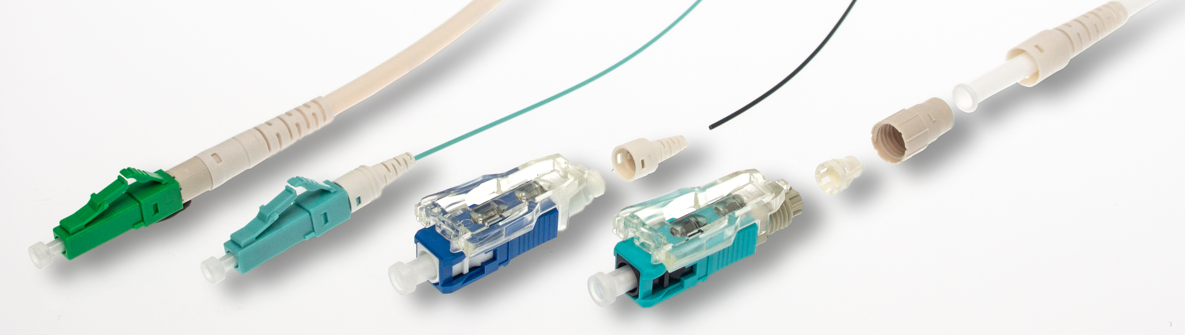 Figure 1: FFP connectors are available for cable mounting and for wire mounting.

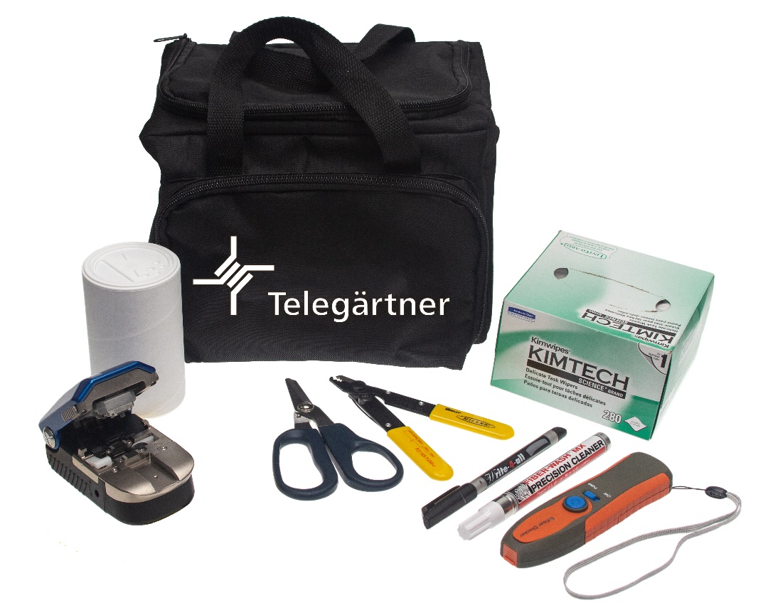
Figure 2: The FFP toolkits contain what is needed to mount the FFP. If you already own a cleaver, you can order a particularly inexpensive kit without one.

Steinenbronn - 23.02.2021. Modern, high-performance FTTx fibre optic networks such as Fiber-To-The-Home (FTTH)/Fiber-In-The-Home (FITH) and Fiber-To-The-Building (FTTB)/Fiber-In-The-Building (FITB) require short installation times. Only a few connectors need to be installed at a number of different locations, but this is usually done under limited space conditions. Gluing, grinding and polishing fibre optic connectors in flats, house connection rooms, basements or mobile phone base stations or splicing them to pigtails is often neither technically sensible nor economically feasible.

The fibre optic connectors of the new FFP series from Telegärtner can be installed on site just as quickly and easily as the connectors of copper cables. Strip the insulation, shorten to the correct length, insert, lock - done! The installer can see at first glance from the viewing windows in the connector housing whether he has fitted the connector correctly and can make further adjustments if necessary.
"The field-terminable fibre optic connectors of our FFP series can be installed quickly, easily and particularly economically without expensive special equipment, extensive training or splicing equipment," says Sarah Fischer, Product Manager DataVoice at Telegärtner. "This means that businesses that were previously closed to the fibre optic market can also benefit from the increasing FTTx projects."
The simple installation also makes the FFP connectors ideal for quick on-site repairs.
The optical values are at the same high level as with classic adhesive connectors. For example, the typical insertion loss (IL) for the multimode connectors is only 0.1 dB, and the attenuation change at 500 mating is less than 0.1 dB. And with an operating temperature of -40 °C to +75 °C with wire assembly, the FFPs are also suitable for a wide range of smart city applications.
"Field-terminable fibre optic connectors are now just as durable and long-term stable as adhesive connectors," Fischer continues. "Quality is one of our company principles."
Telegärtner's FFP series includes LC and SC connectors for OS2 single-mode and OM3 multimode fibres. The single-mode connectors are also available in an APC version with bevel grinding, and the multimode connectors can also be used for routes with OM4 fibres without any loss in performance. In order to meet the requirements of as many applications as possible, the connectors are available in cable assembly versions for wire insulation with a diameter of 2 millimetres and with 3 millimetres as well as for wire assembly; this version can be used for fibres with 250 µm coating as well as with 900 µm coating, which simplifies stock-keeping.
If two packaging units with 10 or 12 connectors each are purchased, an assembly aid is included free of charge. Various tool sets (toolkits) are also available. As no special tools are required, the sets contain standard tools such as stripping pliers, Kevlar scissors and a light source for checking the assembled connectors. They differ only in the scoring/breaking tool (cleaver): with premium or standard cleaver or without, if the installer already has one. This also contributes to the special economic efficiency.

About Telegärtner
Telegärtner, founded in 1945, is a globally operating full-range supplier for professional solutions in connection and transmission technology and is one of the most important manufacturers. The family-owned company, rich in tradition, is now in its third generation of management. With around 660 employees worldwide, the group recently generated sales of over EUR 100 million.

Press contact: Telegärtner Karl Gärtner GmbH
Lerchenstrasse 35
D-71144 Steinenbronn
Tel central office: +49 7157/125-0
Website: http://www.telegaertner.com

